2020 Census Social Media Resource Guide
Here are sample twitter posts, PSAs, and photos you can use on your department’s social media channels. These photos and videos can be used in conjunction with any of these tweets. Feel free to add a personal touch to tailor it to your community. We recommend you share one post per week to reach your audiences and share helpful information about the 2020 census. Additional outreach resources in more than 10 different languages can be accessed here.
Tweets | PSAs | Photos
We are excited to announce that [insert your department name] is partnering with @DC_AMCHP and the @uscensusbureau to support the 2020 Census! As a partner, we’ll be working to ensure that all children in the US are accurately counted. To learn about the upcoming census, visit 2020census.gov. #2020Census #transformMCH | They Also Count:  https://2020census.gov/en/partners/psa-toolkit/they-count.html | 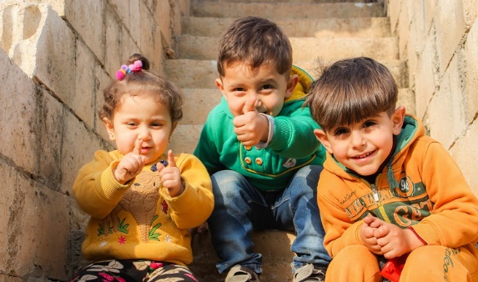
Every 10 years, the @uscensusbureau counts all people in the US. This includes all children – from newborn babies to teenagers. When you respond to the census, you help your community get its fair share of funding for important programs that serve all children. Learn more about the #2020Census at 2020census.gov. #transformMCH | What I Learned Today:  https://2020census.gov/en/partners/psa-toolkit/learn.html | 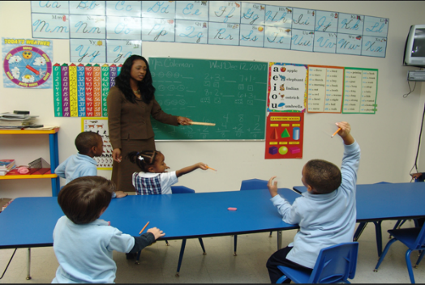
In 2010, nearly one million young children were not counted in the census. If young children are not counted in the 2020 census, it means that for the next decade, your state could get less funding for programs that children depend upon. Make sure all kids are counted! #2020Census #transformMCH | Every Moment Counts:  https://2020census.gov/en/partners/psa-toolkit/moment.html | 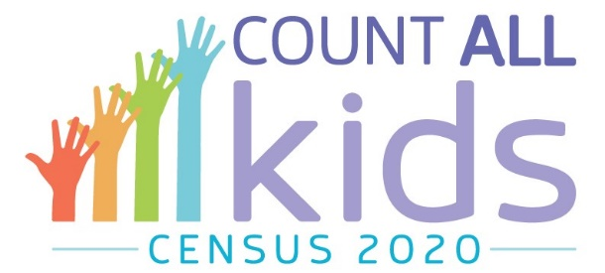
What matters most to you? Children’s health insurance? Schools? Child nutrition programs? Data from the US census affect many programs that are vitally important for child well-being. To learn how census data impact you and your community, visit 2020census.gov. #2020Census #transformMCH | The 2020 Census Made Simple: https://2020census.gov/en/partners/psa-toolkit/made-simple.html | 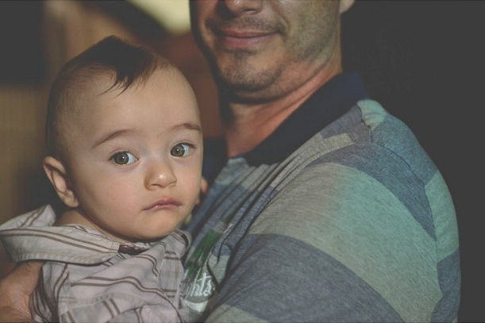
What children should you include on your census form? Your kids? Grandkids? Nieces & nephews? Newborns in the hospital? All the above! Any child who lives in your home should be included on your census form. Make sure all kids are counted! #2020Census #transformMCH | Seven-Year-Old Singer Promotes the Census: https://youtu.be/n42OB_VFs3M
The @uscensusbureau takes your privacy seriously! Your answers are only used to count the number of people in the country. The government will not share your answers with anyone. Please complete the census form! The country needs an accurate count of all kids! #2020Census #transformMCH | Counting Young Children in the 2020 Census:  https://www.census.gov/content/dam/Census/newsroom/press-kits/2018/counting-young-children-in-2020-census.pdf | 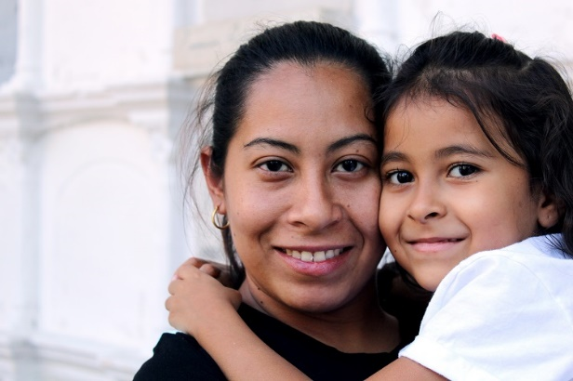
Did you know that instructions are available in over 60 languages, to help you, your friends, and family members complete the #2020Census? https://www.census.gov/programs-surveys/decennial-census/2020-census/planning-management/language-resources/language-guides.html. #transformMCH |  | 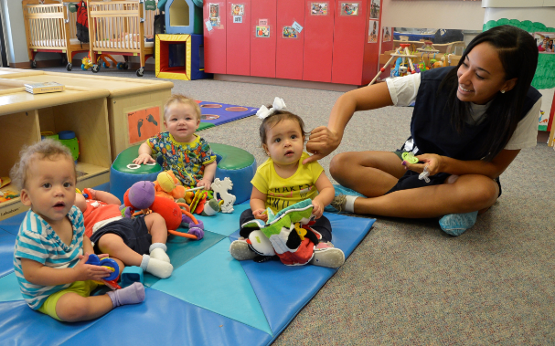
In 2020, for the first time ever, the @uscensusbureau will accept responses online and by phone, but you can still respond by mail if you prefer. Fill out your census form! It’s important for our kids and their future! #2020Census #transformMCH |  | 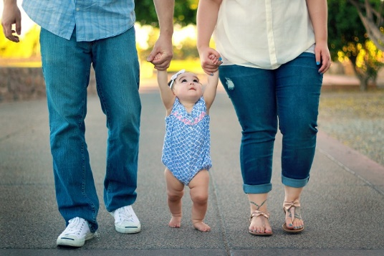
Census data will help state and local governments plan for the future and determine where $800 billion a year in federal funding goes, including Medicaid, WIC, childcare, public schools, and low-income housing. Join the effort to count all kids! #2020Census #transformMCH |  | 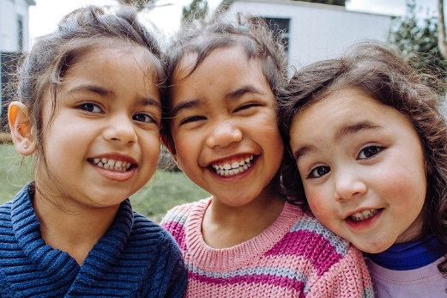
The “Hard to Count” map (censushardtocountmaps2020.us) provides information about children throughout the US at risk of being missed in the census count. Join the effort to count all kids! #2020Census #transformMCH |  | 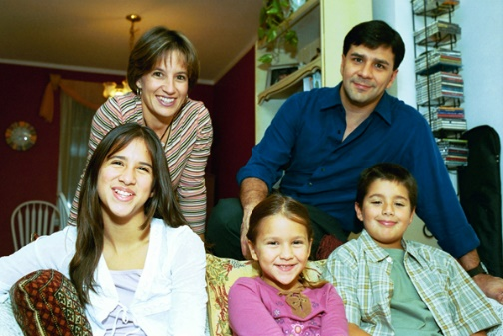
Having a busy day with your kids? The census form only takes about 10 minutes to complete, and you can fill it out online, on paper or over the phone, at a time that works best for you. Make sure your kids are counted! #2020Census #transformMCH |  | 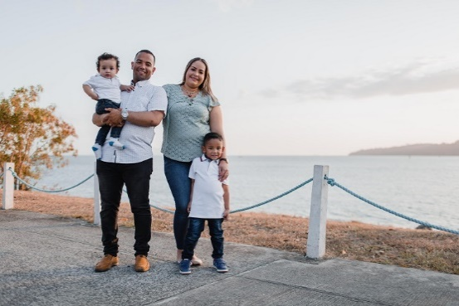
Responding to the census helps determine $675 billion in local funding for programs such as the Children’s Health Insurance Program, SNAP, and the school lunch program. When kids are missed in the census, these programs can lose funding that’s based on the number of children counted. #2020Census #transformMCH |  | 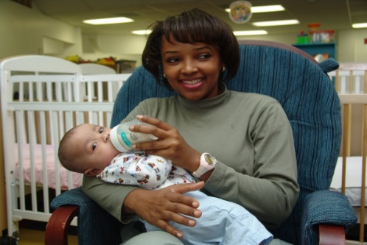
What’s something easy, safe, and important you can do to ensure your child has the resources they need? Filling out the US census! Make sure your kids are counted so that the programs they use get the funding they need. #2020Census #transformMCH

